* 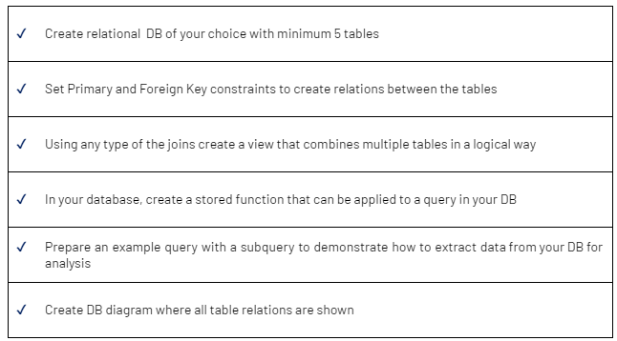

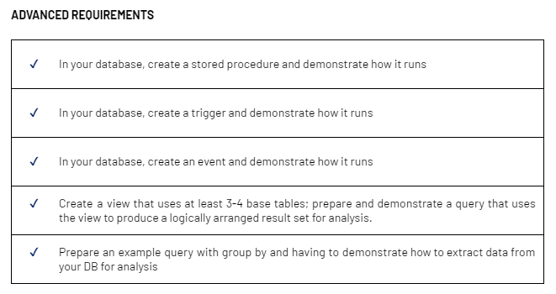

* **Tables required to organise the Hunger Games:**

Districts:

* + District_ID (Primary Key)
  + District_Name
  + District_Descriptor
* Tributes:
  + Tribute_ID (Primary Key)
  + FirstName
  + LastName
  + District_ID (Foreign Key referencing Districts)

Age

* + Tribute_ID (Foreign Key referencing Tributes)
  + Age
  + Gender
  + Skills
* Event_Name:
  + Event_ID (Primary Key)
  + Event_Type (e.g., Cornucopia Bloodbath, Tracker Jacker Attack, etc.)
  + Description
  + EventDateTime
* Sponsors:
  + Sponsor_ID (Primary Key)
  + SponsorName
  + Tribute_ID (Foreign Key referencing Tributes)
  + AmountDonated
* Kills:
  + Kill_ID (Primary Key)
  + Killer_ID (Foreign Key referencing Tributes)
  + Victim_ID (Foreign Key referencing Tributes)
  + KillDateTime
  + Location (foreign key referencing Arena_ID)
* Arenas:
  + Arena_ID (Primary Key)
  + ArenaName
  + Description
  + Features (terrain, obstacles, etc.)

Weapons:

* Weapon_ID (Primary Key)
* Weapon_Type

TributeWeapons:

* Tribute_ID (Foreign Key referencing Tributes)
* Weapon_ID(Foreign Key referencing Weapons)

Mentors:

* Mentor_ID (Primary Key)
* FirstName
* LastName
* District_ID (Foreign Key referencing Districts)

**Code to create Hunger Games Database:**

CREATE DATABASE HungerGames;

USE HungerGames;

CREATE TABLE Districts (

District_ID INT NOT NULL,

District_Name VARCHAR(20) NOT NULL,

District_Descriptor VARCHAR(20) NOT NULL,

PRIMARY KEY(District_ID)

);

CREATE TABLE Weapons (

Weapon_ID INT NOT NULL,

Weapon_Type VARCHAR(50) NOT NULL,

PRIMARY KEY(Weapon_ID)

);

CREATE TABLE Tributes (

Tribute_ID INT,

FirstName VARCHAR(20) NOT NULL,

LastName VARCHAR(20) NOT NULL,

District_ID INT NOT NULL,

PRIMARY KEY (Tribute_ID),

CONSTRAINT FK_DISTRICT

FOREIGN KEY(District_ID)

REFERENCES Districts(District_ID)

);

CREATE TABLE Age (

Tribute_ID INT,

Age INT NOT NULL,

Gender VARCHAR(2) NOT NULL,

Skills VARCHAR(20) NOT NULL,

CONSTRAINT FK_ID_TRIBUTE

FOREIGN KEY(Tribute_ID)

REFERENCES Tributes(Tribute_ID)

);

CREATE TABLE Tribute_Weapons (

Tribute_ID INT NOT NULL,

Weapon_ID INT NOT NULL,

CONSTRAINT FK_Weapon_Tribute

FOREIGN KEY (Tribute_ID)

REFERENCES Tributes(Tribute_ID),

CONSTRAINT FK_Weapon_ID

FOREIGN KEY (Weapon_ID)

REFERENCES Weapons(Weapon_ID)

);

CREATE TABLE Event_Name (

Event_ID INT NOT NULL,

Event_Type VARCHAR(50) NOT NULL,

Description VARCHAR(150) NOT NULL,

EventDateTime datetime,

PRIMARY KEY(Event_ID)

);

CREATE TABLE Arenas (

Arena_ID INT NOT NULL,

ArenaName VARCHAR(20) NOT NULL,

Description VARCHAR(150) NOT NULL,

Features VARCHAR(50),

PRIMARY KEY (Arena_ID)

);

CREATE TABLE Sponsors (

Sponsor_ID INT NOT NULL,

SponsorName VARCHAR (20),

Tribute_ID INT NOT NULL,

AmountDonated DECIMAL (12, 2),

PRIMARY KEY(Sponsor_ID),

CONSTRAINT FK_Tribute_ID

FOREIGN KEY(Tribute_ID)

REFERENCES Tributes(Tribute_ID)

);

CREATE TABLE Kills (

Kill_ID INT NOT NULL,

Killer_ID INT,

Victim_ID INT,

KillDateTime DATETIME,

Location INT,

PRIMARY KEY(Kill_ID),

CONSTRAINT FK_Killer_ID

FOREIGN KEY(Killer_ID)

REFERENCES Tributes(Tribute_ID),

CONSTRAINT FK_Victim_ID

FOREIGN KEY(Victim_ID)

REFERENCES Tributes(Tribute_ID),

CONSTRAINT FK_Location

FOREIGN KEY(Location)

REFERENCES Arenas(Arena_ID)

);

CREATE TABLE Mentors (

Mentor_ID INT NOT NULL,

FirstName VARCHAR(50) NOT NULL,

LastName VARCHAR(50) NOT NULL,

District_ID INT NOT NULL,

PRIMARY KEY (Mentor_ID),

Constraint FK_District_ID

FOREIGN KEY (District_ID)

REFERENCES Districts(District_ID)

);

**Data Info:**

USE HungerGames;

INSERT INTO Districts (District_ID, District_Name, District_Descriptor)

VALUES

(1, 'District 1', 'Luxury'),

(2, 'District 2', 'Masonry'),

(3, 'District 3', 'Technology'),

(4, 'District 4', 'Fishing'),

(5, 'District 5', 'Power'),

(6, 'District 6', 'Transportation'),

(7, 'District 7', 'Lumber'),

(8, 'District 8', 'Textiles'),

(9, 'District 9', 'Grain'),

(10, 'District 10', 'Livestock'),

(11, 'District 11', 'Agriculture'),

(12, 'District 12', 'Mining');

INSERT INTO Tributes (Tribute_ID, FirstName, LastName, District_ID)

VALUES

(1, 'Katniss', 'Everdeen', 12),

(2, 'Peeta', 'Mellark', 12),

(3, 'Cato', 'Hadley', 2),

(4, 'Rue', 'Lorin', 11),

(5, 'Finnick', 'Odair', 4),

(6, 'Johanna', 'Mason', 7),

(7, 'Glimmer', 'Summers', 1),

(8, 'Thresh', 'Sonner', 11),

(9, 'Beetee', 'Latier', 3),

(10, 'Annie', 'Cresta', 4),

(11, 'Lester','Watt',5),

(12,'Amber', 'Fiate', 6),

(13,'Odin','Cottons', 8),

(14, 'Felicity','Jower', 9),

(15,'Dream','Lambe',10);

INSERT INTO Age (Tribute_ID, Age, Gender, Skills)

VALUES

(1, 17, 'F', 'Archery'),

(2, 18, 'M', 'Baking'),

(3, 18, 'M', 'Swordsmanship'),

(4, 12, 'F', 'Botany'),

(5, 24, 'M', 'Trident proficiency'),

(6, 22, 'F', 'Axe throwing'),

(7, 21, 'F', 'Throwing knives'),

(8, 20, 'M', 'Strength'),

(9, 32, 'M', 'Electronics'),

(10, 23, 'F', 'Swimming'),

(11, 16, 'M', 'Electronics'),

(12, 15, 'F', 'Metal Working'),

(13, 17, 'M', 'Axe Throwing'),

(14, 13, 'F', 'Botany'),

(15, 18, 'F', 'Camoflage');

INSERT INTO Event_Name (Event_ID, Event_Type, Description, EventDateTime)

VALUES

('1', 'Opening Ceremony', 'Grand opening of the Hunger Games', '2022-05-01 12:00:00'),

('2', 'Bloodbath', 'Initial fight for resources', '2022-05-02 09:00:00'),

('3', 'Alliance Formation', 'Tributes form alliances for survival', '2022-05-03 14:30:00'),

('4', 'Mutant Encounter', 'Tributes face off against mutant creatures', '2022-05-04 11:45:00'),

('5', 'Sponsor Gifts', 'Capitol sponsors send gifts to tributes', '2022-05-05 18:00:00'),

('6', 'Aerial Assault', 'Capitol-controlled drones attack tributes', '2022-05-06 16:30:00'),

('7', 'Tribute Interviews', 'Tributes showcase their skills and stories', '2022-05-07 10:00:00'),

('8', 'Midnight Feast', 'A feast with essential supplies announced at midnight', '2022-05-08 00:00:00'),

('9', 'Tribute Revolt', 'Tributes rebel against Capitol control', '2022-05-09 13:15:00'),

('10', 'Final Showdown', 'The last tributes face off for victory', '2022-05-10 17:45:00');

INSERT INTO Sponsors (Sponsor_ID, SponsorName, Tribute_ID, AmountDonated)

VALUES

(1, 'Capitol Sponsor 1', 1, 500.00),

(2, 'District 2 Sponsor', 3, 300.00),

(3, 'Capitol Sponsor 2', 5, 700.00),

(4, 'District 11 Sponsor', 8, 250.00),

(5, 'Capitol Sponsor 3', 10, 450.00),

(6, 'District 12 Sponsor', 12, 200.00),

(7, 'Capitol Sponsor 4', 2, 600.00),

(8, 'District 4 Sponsor', 4, 350.00),

(9, 'Capitol Sponsor 5', 6, 400.00),

(10, 'District 7 Sponsor', 7, 320.00),

(11, 'District 9 Sponsor', 14, 100.00),

(12, 'Capitol Sponsor 6', 1, 320.00);

INSERT INTO Arenas (Arena_ID, ArenaName, Description, Features)

VALUES

(1, 'Forest Arena', 'A dense forest with hidden dangers', 'Mutant creatures, traps'),

(2, 'Mountain Arena', 'Treacherous mountain terrain', 'Rockslides, thin air'),

(3, 'Desert Arena', 'Endless sand dunes under scorching sun', 'Sandstorms, oasis'),

(4, 'Frozen Tundra', 'A frigid landscape with icy winds', 'Frozen lakes, ice caves'),

(5, 'Urban Jungle', 'Abandoned city with overgrown vegetation', 'Collapsed buildings, hidden passages'),

(6, 'Volcanic Crater', 'A smoky and dangerous volcanic crater', 'Lava pits, volcanic eruptions'),

(7, 'Underground Bunker', 'A network of dark and claustrophobic tunnels', 'Booby traps, limited visibility'),

(8, 'Island Paradise', 'Tropical island surrounded by treacherous waters', 'Sharks, coral reefs'),

(9, 'Sky High Arena', 'Floating islands in the sky', 'Floating platforms, unpredictable weather'),

(10, 'Maze of Mirrors', 'A confusing labyrinth of mirrors', 'Illusions, disorientation');

INSERT INTO Kills (Kill_ID, Killer_ID, Victim_ID, KillDateTime,Location)

VALUES

(1, 3, 15, '2022-05-02 09:01:00',1), -- Cato kills Dream

(2, 7, 12, '2022-05-02 09:05:00',1), -- Glimmer kills Amber

(3, 14, 11, '2022-05-02 09:27:00',1), -- Felicity kills Lester

(4, 13, 10, '2022-05-03 10:30:00',3), -- Odin kills Annie

(5, 1, 6, '2022-05-04 11:50:00',2), -- Cato Kills Joanna

(6, 8, 7, '2022-05-04 12:05:00',4), -- Thresh Kills Glimmer

(7, 5, 13, '2022-05-05 09:30:00',7), -- Finnick Kills Odin

(8, 3, 4, '2022-05-05 16:30:00',5), -- Cato Kills Rue

(9, 2, 14, '2022-05-05 16:56:00',5), -- Peeta Kills Felicity

(10, 5, 8, '2022-05-06 09:30:00',9), -- Finnick kills Thresh

(11, 9, 5, '2022-05-08 13:40:00',10), -- Beetee Killed Finnick

(12, 3, 9, '2022-05-09 14:15:00',6), -- Cato killed Beetee

(13, 1, 3, '2022-05-10 12:10:00',8); -- katniss killed Cato

INSERT INTO Weapons (Weapon_ID, Weapon_Type)

VALUES

(1,'Bow and Arrow'),

(2,'Long Knife'),

(3,'Sword'),

(4,'Trident'),

(5,'Spear'),

(6,'Mace'),

(7,'Sickle'),

(8,'Small Knife'),

(9,'Machete'),

(10,'Javelin'),

(11,'Katana'),

(12,'Blow Darts'),

(13,'Hatchet'),

(14,'Axe');

INSERT INTO Mentors (Mentor_ID, FirstName, LastName, District_ID)

VALUES

(1,'Haymitch','Abernathy', 1),

(2,'Nirali','Shah', 2),

(3,'Michaela','Wegg', 3),

(4,'Ceri','PattersonNairn', 4),

(5,'Carol','Bryce', 5),

(6,'Rachael','Rowbottom', 6),

(7,'Vanny','Coding', 7),

(8,'Zoe','Data', 8),

(9,'Eric','Nairn', 9),

(10,'Connor','Groden', 10),

(11,'Milo','Crisp', 11),

(12,'Aayush','Woosh', 12);

INSERT INTO Tribute_Weapons ( Tribute_ID, Weapon_ID)

VALUES

(1,1),

(2,2),

(3,3),

(5,4),

(15,5),

(14,6),

(11,7),

(4,1),

(8,9),

(3,10),

(12,11),

(14,12),

(13,13),

(6,14),

(9,2),

(10,3),

(8,5),

(1,8),

(7,1),

(13,14);

**Tables:**

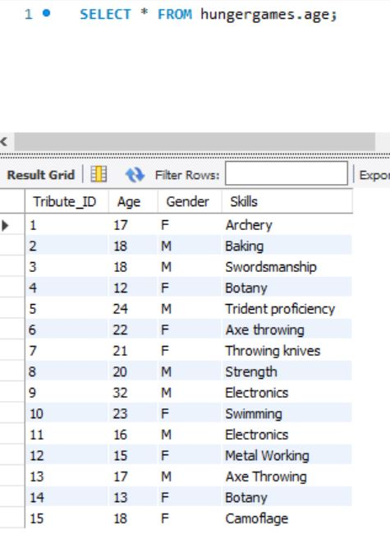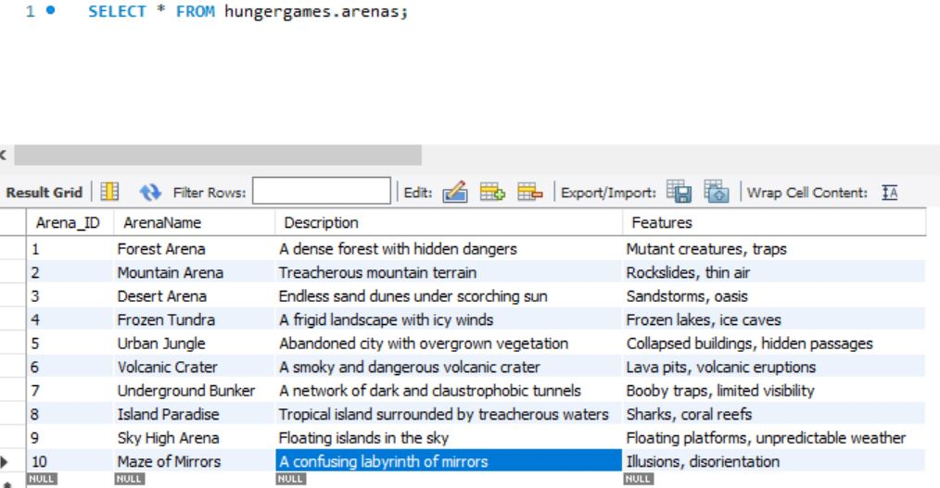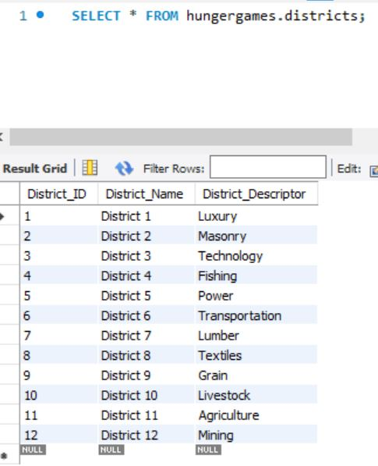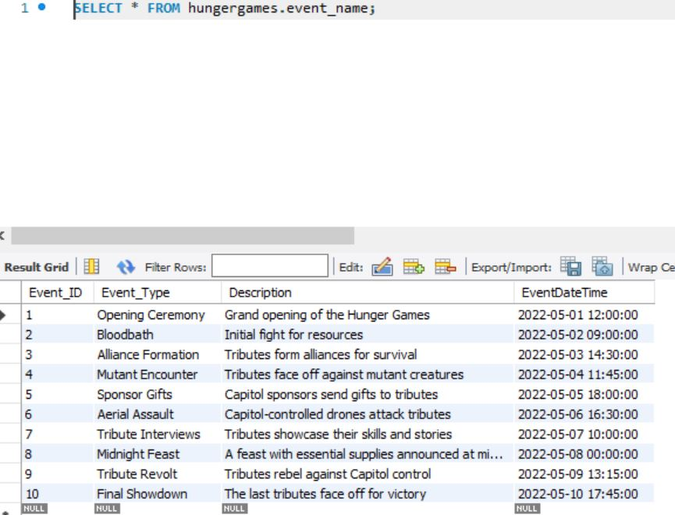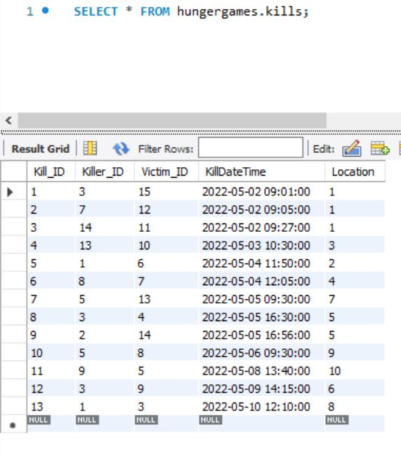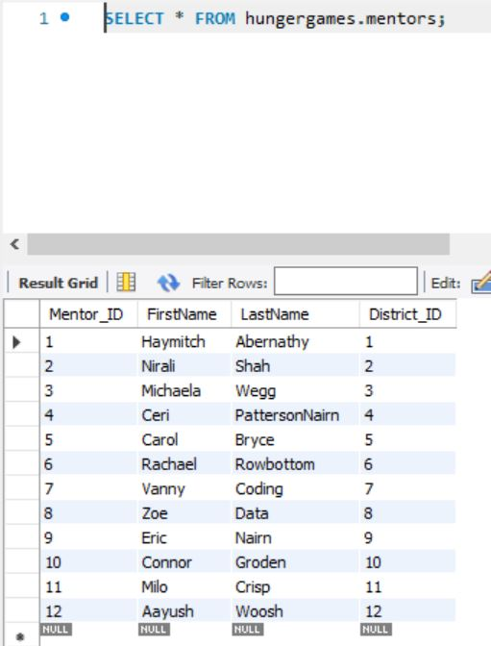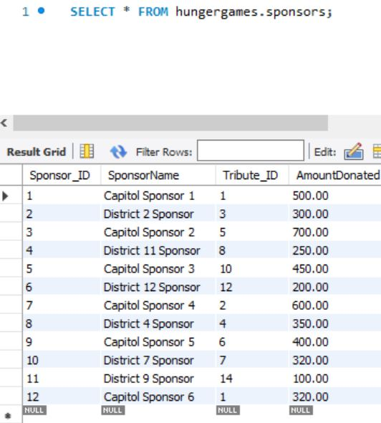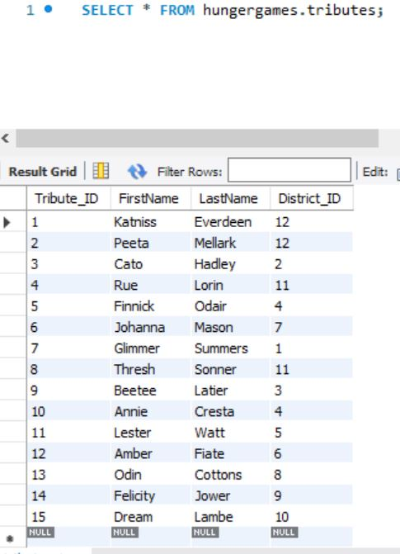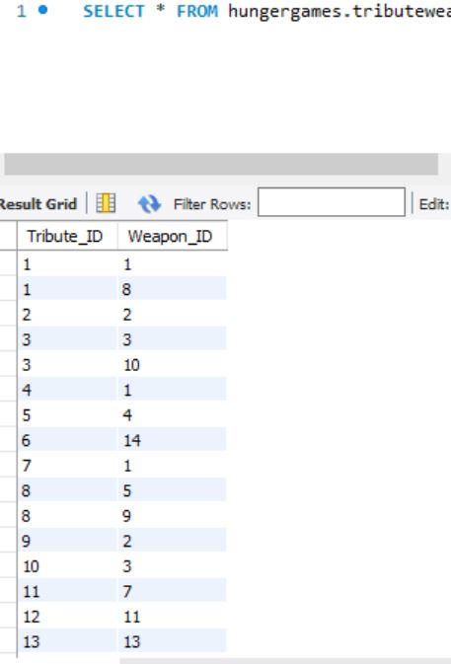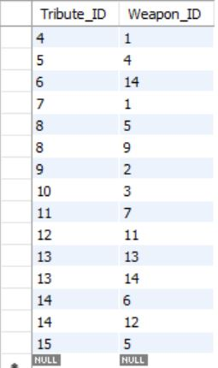

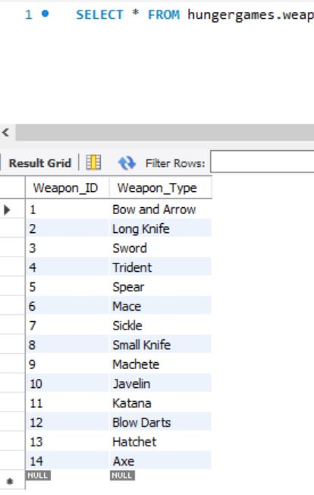

**EER Diagram:**

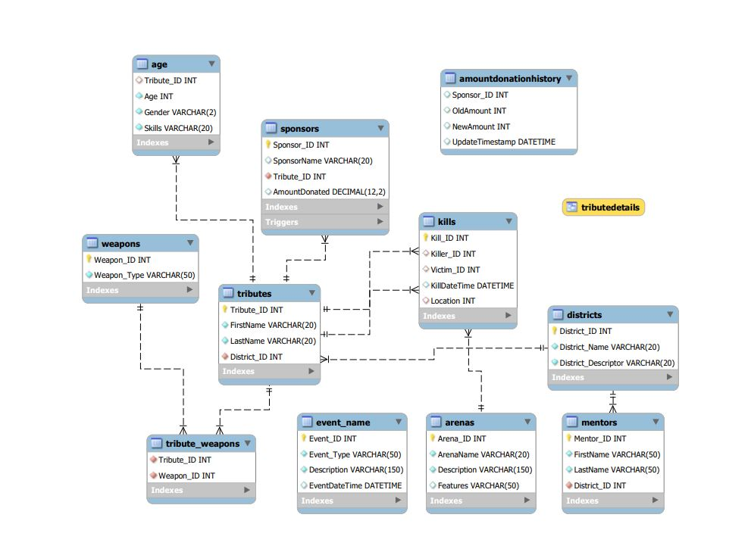

**Create a view using multiple tables**

**Using five tables (‘Tributes’, ‘Districts’, ‘Age’, ‘Weapons’ and ‘Sponsors’):**

USE HungerGames;

CREATE VIEW TributeDetails AS

SELECT

tributes.Tribute_ID,

tributes.FirstName,

tributes.LastName,

districts.District_Name,

age.Age,

age.Gender,

age.Skills,

weapons.Weapon_Type,

sponsors.SponsorName

FROM

tributes

LEFT JOIN districts ON tributes.District_ID = districts.District_ID

LEFT JOIN age ON tributes.Tribute_ID = age.Tribute_ID

LEFT JOIN Tribute_Weapons ON tributes.tribute_ID = Tribute_Weapons.Tribute_ID

LEFT JOIN weapons ON Tribute_Weapons.Weapon_ID = weapons.Weapon_ID

LEFT JOIN sponsors ON tributes.Tribute_ID = sponsors.Tribute_ID;

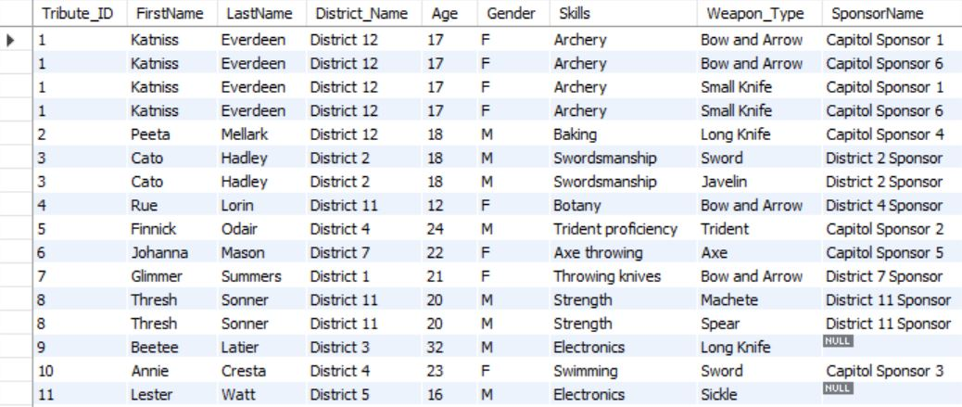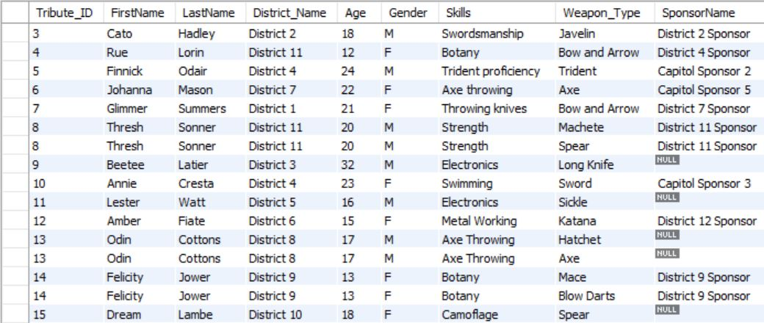

**Stored Procedure:**

DELIMITER //

CREATE PROCEDURE GetTributeStatus(IN p_Tribute_ID INT)

BEGIN

DECLARE v_IsAlive BOOLEAN;

DECLARE v_KillerName VARCHAR(50);

DECLARE v_ArenaName VARCHAR(50);

DECLARE v_EventName VARCHAR(50);

DECLARE v_EventDateTime DATETIME;

-- Check if the tribute is alive

SELECT COUNT(*) INTO v_IsAlive

FROM Kills

WHERE Victim_ID = p_Tribute_ID;

IF v_IsAlive = 0 THEN

-- Tribute is alive

SELECT 'Alive' AS Status, FirstName FROM Tributes

WHERE Tribute_ID = p_Tribute_ID;

ELSE

-- Tribute is dead, get details

-- below part is finding all the connections with the id number we have passed in

SELECT

tk.FirstName AS KillerName,

a.ArenaName,

en.Event_Type AS EventName,

en.EventDateTime

INTO

v_KillerName,

v_ArenaName,

v_EventName,

v_EventDateTime

FROM Kills k

JOIN

Tributes tk ON k.Killer_ID = tk.Tribute_ID

JOIN

Arenas a ON k.Location = a.Arena_ID

JOIN

Event_Name en ON

en.EventDateTime = (

SELECT MAX(EventDateTime)

FROM Event_Name

WHERE EventDateTime <= k.KillDateTime

)

-- the above subquery is checking the kill time with event time ranges. What it is doing is getting the last possible published time and then comparing it with kill time so if it is earlier than the last event time, then it is part of the earlier event and so on.

WHERE k.Victim_ID = p_Tribute_ID

ORDER BY en.EventDateTime

LIMIT 1;

-- below part is returning for output

SELECT

'Dead' AS Status,

tk.FirstName AS Tribute,

v_KillerName AS Killer,

v_ArenaName AS Arena,

v_EventName AS EventName

FROM Kills k

JOIN

Tributes tk ON k.Victim_ID = tk.Tribute_ID

WHERE

k.Victim_ID = p_Tribute_ID;

END IF;

END //

--this procedure gives us in which arena was the tribute killed and who killed them, in case the tribute was alive at the end it will just give us the status alive

**Trigger:**

DELIMITER //

CREATE TRIGGER AfterUpdateAmountDonated

AFTER UPDATE ON Sponsors

FOR EACH ROW

BEGIN

IF NEW.AmountDonated <> OLD.AmountDonated THEN

INSERT INTO AmountDonationHistory (Sponsor_ID, OldAmount, NewAmount, UpdateTimestamp)

VALUES (NEW.Sponsor_ID, OLD.AmountDonated, NEW.AmountDonated, NOW());

END IF;

END//

DELIMITER ;

**Event:**

SET GLOBAL event_scheduler = ON;

DELIMITER //

CREATE EVENT IF NOT EXISTS DailyDonationEvent

ON SCHEDULE

EVERY 1 DAY

STARTS TIMESTAMP('2022-05-01 00:00:00')

DO

BEGIN

UPDATE Sponsors

SET AmountDonated = AmountDonated + 100.00

WHERE SponsorName = 'Capitol Sponsor 1';

END //

DELIMITER ;

--This event is set to run every day, at midnight. It updates the `AmountDonated` for 'Capitol Sponsor 1', adding 100.00 to the existing amount.

**Stored Function:**

DELIMITER //

CREATE FUNCTION DonationStats(TributeID INT)

RETURNS INT

DETERMINISTIC

BEGIN

DECLARE totalDonation INT;

-- Initialize totalDonation to 0

SET totalDonation = 0;

-- Check if the Tribute_ID exists in the Sponsors table

IF EXISTS (SELECT 1 FROM Sponsors WHERE Tribute_ID = TributeID) THEN

-- Calculate the total donation amount for the specified Tribute_ID

SELECT SUM(AmountDonated) INTO totalDonation

FROM Sponsors

WHERE Tribute_ID = TributeID;

END IF;

RETURN totalDonation;

END;

DELIMITER ;

--This function gives us the total donated amount for tribute input. If the tribute doesnt have any donations( ie doesn’t exist in the sponsor table) the out is 0.

**How to call the stored procedure & stored function:**

CALL GetTributeStatus(2);

SELECT DonationStats(15) AS TotalDonationForTribute;

**Example Subquery:**

SELECT

t.Tribute_ID,

t.FirstName,

t.District_ID,

(

SELECT GROUP_CONCAT(w.Weapon_type SEPARATOR ', ')

FROM tribute_weapons tw

JOIN weapons w ON tw.Weapon_ID = w.Weapon_ID

WHERE tw.Tribute_ID = t.Tribute_ID

) AS AssignedWeapons

FROM

tributes t;

--Uses 3 tables to get the weapons assigned to the tributes

**To run the Trigger:**

--Had to create a new table for this

USE hungergames;

CREATE TABLE AmountDonationHistory(

Sponsor_ID INT,

OldAmount INT,

NewAmount INT,

UpdateTimestamp DATETIME

);

USE hungergames;

-- Perform an update on the Sponsors table to trigger the AfterUpdateAmountDonated event

UPDATE Sponsors

SET AmountDonated = AmountDonated + 50.00

WHERE Sponsor_ID = 1;

**Groupby Query:**

SELECT

tw.Weapon_ID,

w.Weapon_type,

COUNT(t.Tribute_ID) AS TributeCount

FROM

tribute_weapons tw

JOIN

weapons w ON tw.Weapon_ID = w.Weapon_ID

JOIN

tributes t ON tw.Tribute_ID = t.Tribute_ID

GROUP BY

tw.Weapon_ID, w.Weapon_type;

--this uses group_by to get number of tributes that have the same weapon

**Getting info out of the view:**

SELECT

District_Name,

AVG(age) AS AverageAge,

MAX(age) AS MaxAge,

MIN(age) AS MinAge,

COUNT(DISTINCT Tribute_ID) AS TotalTributes,

COUNT(DISTINCT SponsorName) AS TotalSponsors

FROM

tributedetails

GROUP BY

District_Name;

--gives a lot of info using the view. - avg age, max age, min age, total tributes from the district, total sponsors for the district, everything is grouped by the district.